**GOVERNMENT OF TAMILNADU**

DIRECTORATE OF TECHNICAL EDUCATION, CHENNAI

NAAN MUDHALVAN SCHEME (TNSDC) SPONSORED

STUDENTS DEVELOPMENT PROGRAMME

ON

**IoT AND ITS APPLICATIONS**

**HOST INSTITUTION**

xxxx

COIMBATORE – 04

**TRAINING PARTNER**

ENTHU TECHNOLOGY SOLUTIONS INDIA PVT LTD

DATE:

|  |  |
| --- | --- |
| **NAME** | **ROLL NO** |
| Name 1 | Roll no 1 |
| Name 2 | Roll no 2 |
| Name 3 | Roll no 3 |
| Name 4 | Roll no 4 |
| Name 5 | Roll no 5 |

**TABLE OF CONTENTS**

|  |  |  |
| --- | --- | --- |
| **S.NO** | **TITLE** | **PAGE NO** |
| 1 | ABSTRACT | 1 |
| 2 | INTRODUCTION | 2 |
| 3 | HARDWARE AND SOFTWARE REQUIREMENTS | 3 |
| 4 | BLOCK DIAGRAM | 10 |
| 5 | CODE | 11 |
| 6 | OUTPUT RESULTS | 16 |
| 7 | CLOUD OUTPUT | 17 |
| 8 | CONCLUSION | 18 |

**ABSTRACT**

The need for effective and affordable security systems has grown significantly with the increasing concerns about property theft and unauthorized access. This project presents the development of a simple, cost-effective anti-theft security system using an ESP32 microcontroller, a PIR (Passive Infrared) sensor, an LED, and a buzzer. The system is designed to detect motion within a specified area and respond immediately by activating both a visual and audible alarm, thus providing a robust deterrent against potential intruders.The ESP32 microcontroller, with its advanced features, including built-in Wi-Fi and Bluetooth, serves as the core processing unit for the system. The PIR sensor detects motion by sensing changes in infrared radiation, typically emitted by human bodies. Upon detecting motion, the system triggers the LED to light up and the buzzer to sound, alerting the surroundings to possible unauthorized access.This anti-theft system is not only easy to implement but also highly adaptable, making it suitable for various security applications in residential, commercial, and industrial environments. The project demonstrates how readily available electronic components can be integrated into a practical security solution, offering an effective, low-cost option for enhancing safety and security.

1

**INTRODUCTION**

In an era where security concerns are paramount, especially in homes and small businesses, developing cost-effective and reliable security solutions is essential. This project focuses on creating a simple yet effective anti-theft security system using the ESP32 microcontroller, a PIR (Passive Infrared) sensor, an LED, and a buzzer.The ESP32, known for its powerful processing capabilities and built-in Wi-Fi and Bluetooth, serves as the core of this system. The PIR sensor is employed to detect motion, making it ideal for identifying unauthorized access in a monitored area. When motion is detected, the system triggers both a visual alert through the LED and an audible alarm via the buzzer, alerting users to potential intrusions.This project offers a low-cost, efficient solution for enhancing security in various settings. By leveraging the versatility of the ESP32 and the simplicity of the PIR sensor, this anti-theft system can be easily implemented and customized for different environments, providing an accessible entry point into the world security solutions.

2

**HARDWARE AND SOFTWARE REQUIREMENTS**

**HARDWARE REQUIREMENT**

**1.ESP32 Microcontroller**

**2.PIR Sensor**

**3 .LED**

**4.BUZZER**

**5.Jumper Wires**

**6.USB Cable**

**SOFTWARE REQUIREMENT**

**1.Wokwi Simulator**

**2.Arduino IDE**

**3.ThingzMate Cloud**

3

**ESP32 Microcontroller**

The ESP32 is a highly versatile microcontroller developed by Espressif Systems, designed for a wide range of applications, particularly in the Internet of Things (IoT) space. It is renowned for its combination of high performance, integrated wireless connectivity, and a rich set of features, all at a low cost. The ESP32 is commonly used in projects that require both Wi-Fi and Bluetooth capabilities, making it suitable for smart home devices, sensor networks, and wearable technology.

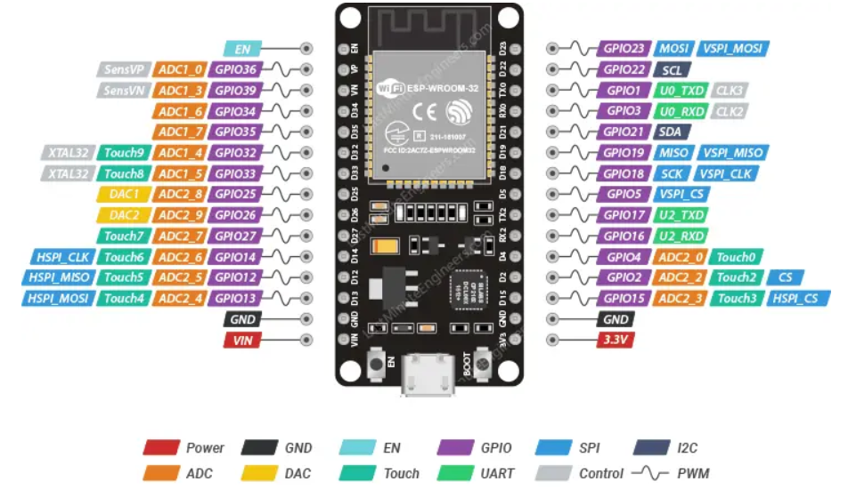

4

**PIR Sensor**

All living objects, whose body temperature is more than 0°C, emit the heat in form of infrared radiation through their body, also called as thermal radiations. This Radiated energy is invisible to human eye. These Signals can be detected by using PIR sensor which is specially designed for such purpose. PIR sensor i.e. Passive Infrared Sensor, passive word indicates PIR Sensor does not generate or radiate any energy for detection purposes. PIR Sensors don't detect or measure "HEAT"; they detect the infrared radiation emitted or reflected from objects. They are small, inexpensive, low power and easy to use. They are commonly found at home, medical, factories etc. areas.

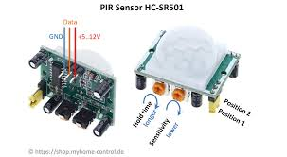

5

**LED**

An LED (Light Emitting Diode) is a semiconductor light source that emits light when an electric current passes through it. It is one of the most energy-efficient and long-lasting lighting technologies available. LEDs are widely used in various applications, from simple indicators to complex displays, due to their small size, low power consumption, and durability. In the context of an anti-theft security system, the LED serves as a visual indicator to signal the detection of motion. When the PIR sensor detects movement, the ESP32 microcontroller sends a signal to the LED, causing it to light up. This visual alert can help in quickly identifying the presence of an intruder or unauthorized access in the monitored area.The LED’s immediate response and visibility make it an effective component for such security systems, providing an instant indication of a security breach.

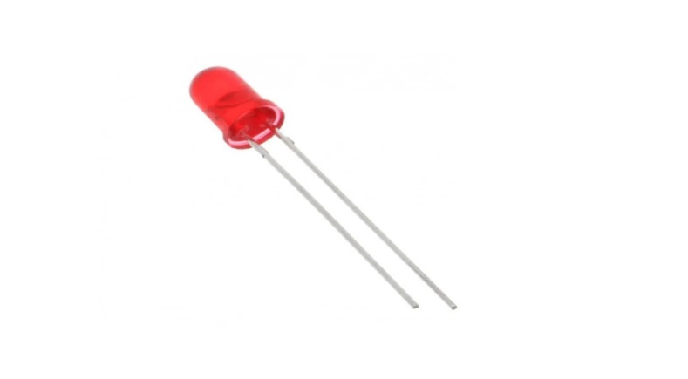

6

**BUZZER**

A buzzer is an electromechanical or electronic device designed to emit an audible sound, commonly used as a signaling or alerting mechanism. Buzzers operate by converting electrical energy into sound through the rapid movement of a diaphragm or a piezoelectric element. They are widely used in various applications, such as alarms, timers, and electronic devices, to provide notifications or warnings. In some contexts, buzzers are also used in interactive systems, such as game shows, where they signal a participant's response or indicate a turn.

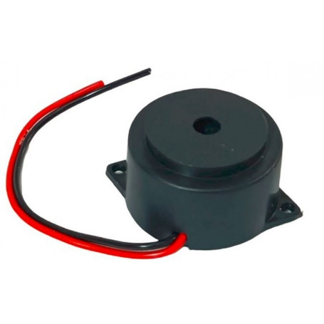

7

**Jumper Wires**

Jumper wires are essential in this project, used to connect the ESP32 microcontroller to the components on the breadboard. These wires provide a flexible and reliable way to link the microcontroller’s GPIO pins to the LEDs, resistors, and other circuit elements, enabling proper signal and power flow. Their ease of use allows for quick modifications and testing during the prototyping stage.

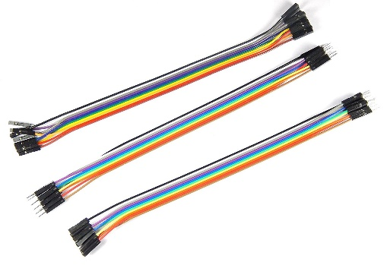

**USB Cable**

The USB cable is a critical tool in this project, used to connect the ESP32 microcontroller to a computer for power supply, programming, and debugging. It enables the transfer of code and data between the development environment and the microcontroller, facilitating the upload of firmware and real-time communication during the development process. The USB connection also allows for serial monitoring, providing valuable insights into the system's performance and behavior.

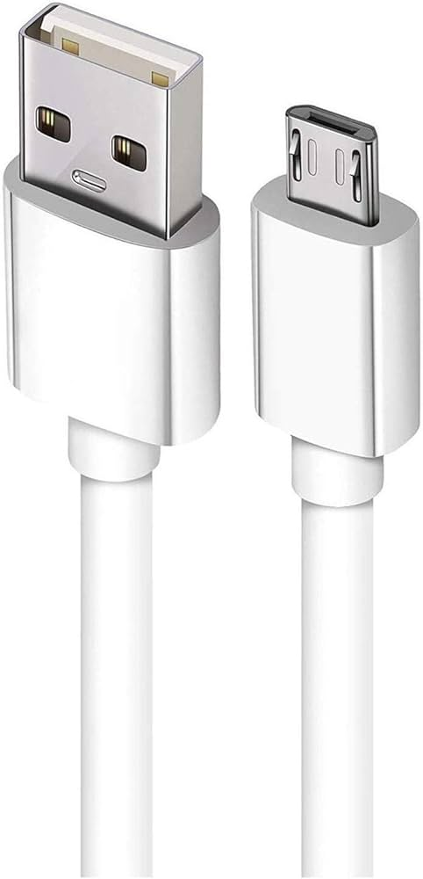

8

**Wokwi Simulator**

To simulate this anti-theft security system using ESP32, PIR sensor, LED, and buzzer on Wokwi, you can create a virtual environment to test the circuit and code. Wokwi allows you to connect these components digitally, providing a platform to visualize the system's operation in response to simulated motion detection. This helps in verifying the functionality before implementing it in a real-world scenario.

**Arduino IDE**

To develop this anti-theft security system, you can use the Arduino IDE to write and upload code to the ESP32. The IDE provides a user-friendly environment for coding, debugging, and interfacing with the ESP32, making it easier to control the PIR sensor, LED, and buzzer. With Arduino IDE, you can quickly implement and test the security system's functionality.

**ThingzMate Cloud**

Integrating the anti-theft security system with Thingzmate Cloud allows you to monitor and control the ESP32 remotely. By connecting the ESP32 to Thingzmate, you can receive real-time alerts and view the status of the PIR sensor, LED, and buzzer from anywhere. This cloud integration enhances the system by providing remote access and data logging capabilities.

9

**BLOCK DIAGRAM**

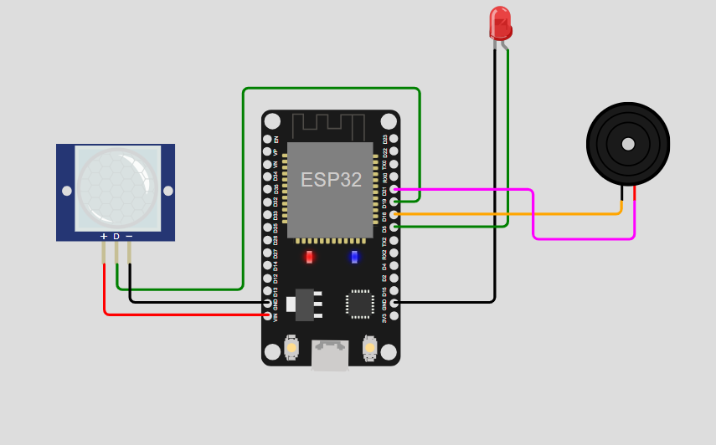

10

**CODE**

#include <WiFi.h>

#include <HTTPClient.h>

// Wi-Fi credentials

#define WIFI_SSID "tyrant"

#define WIFI_PASSWORD "speed123"

// ThingzMate Cloud credentials and server UR

const char* serverUrl = "https://console.thingzmate.com/api/v1/device-types/report1/devices/esp11/uplink"; // Replace with your actual server endpoint

String AuthorizationToken = "Bearer 1078798e0f552d1f4302df43d99b046d"; // Replace with your actual token

// Define the pin for the PIR sensor

#define PIR_SENSOR_PIN 12

#define LED_PIN 13

#define BUZZER_PIN 19

void setup() {

Serial.begin(115200);

delay(4000); // Delay to let serial settle

11

// Connect to WiFi

WiFi.begin(WIFI_SSID, WIFI_PASSWORD);

Serial.print("Connecting to WiFi");

while (WiFi.status() != WL_CONNECTED) {

delay(1000);

Serial.print(".");

}

Serial.println("Connected to WiFi");

// Initialize PIR sensor pin

pinMode(PIR_SENSOR_PIN, INPUT);

pinMode(LED_PIN, OUTPUT);

pinMode(BUZZER_PIN, OUTPUT);

}

void loop() {

// Check PIR sensor

int pirState = digitalRead(PIR_SENSOR_PIN);

if (pirState == HIGH) {

digitalWrite(LED_PIN, HIGH);

digitalWrite(BUZZER_PIN, HIGH);

12

// Motion detected, report to ThingzMate

sendStatusToServer("Alert!!");

} else {

// No motion detected

digitalWrite(LED_PIN, LOW);

digitalWrite(BUZZER_PIN, LOW);

sendStatusToServer("Safe");

}

delay(100); // Small delay to debounce the PIR sensor

}

void sendStatusToServer(String status) {

HTTPClient http;

http.begin(serverUrl);

http.addHeader("Content-Type", "application/json");

http.addHeader("Authorization", AuthorizationToken);

// Create JSON payload

String payload = "{\"status\":\"" + status + "\"}";

// Send POST request

int httpResponseCode = http.POST(payload);

13

if (httpResponseCode > 0) {

String response = http.getString();

Serial.println("HTTP Response code: " + String(httpResponseCode));

Serial.println(response);

} else {

Serial.print("Error code: ");

Serial.println(httpResponseCode);

}

http.end(); // Free resources

}

15

**OUTPUT RESULTS**

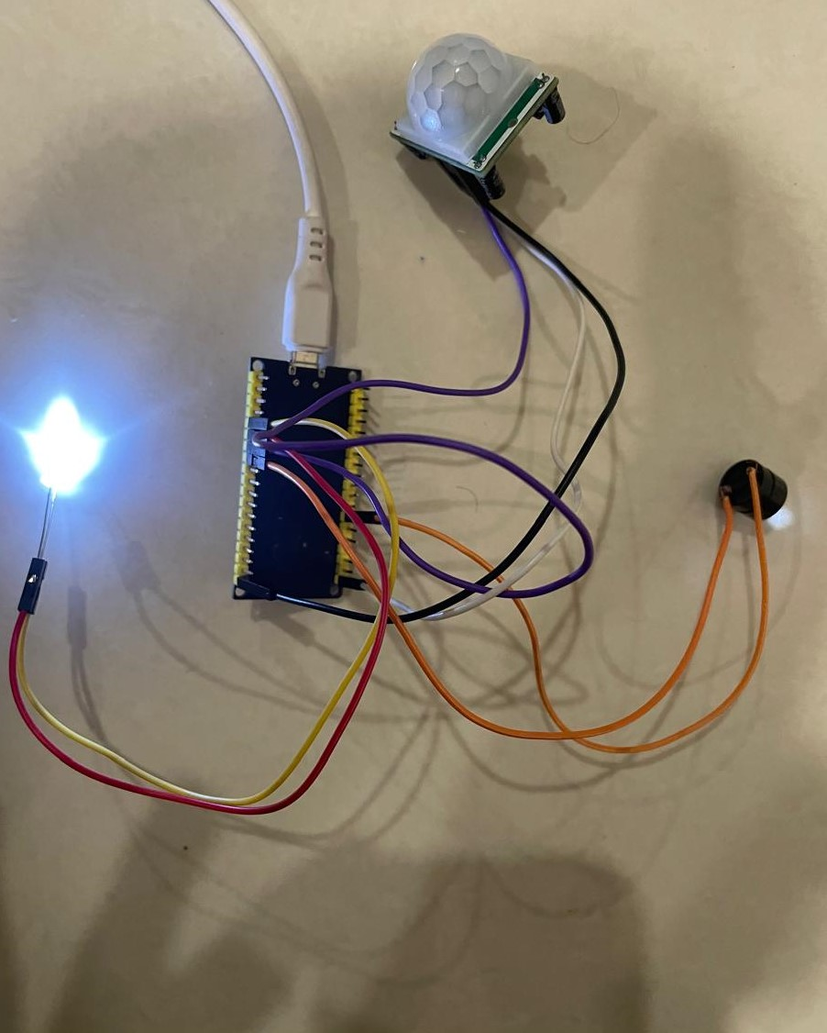

16

**CLOUD OUTPUT**

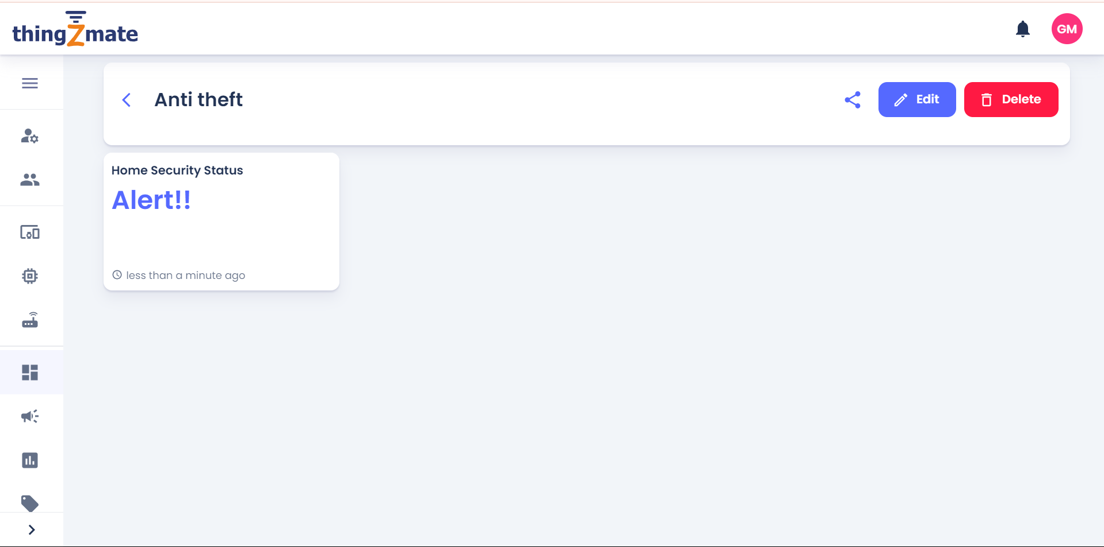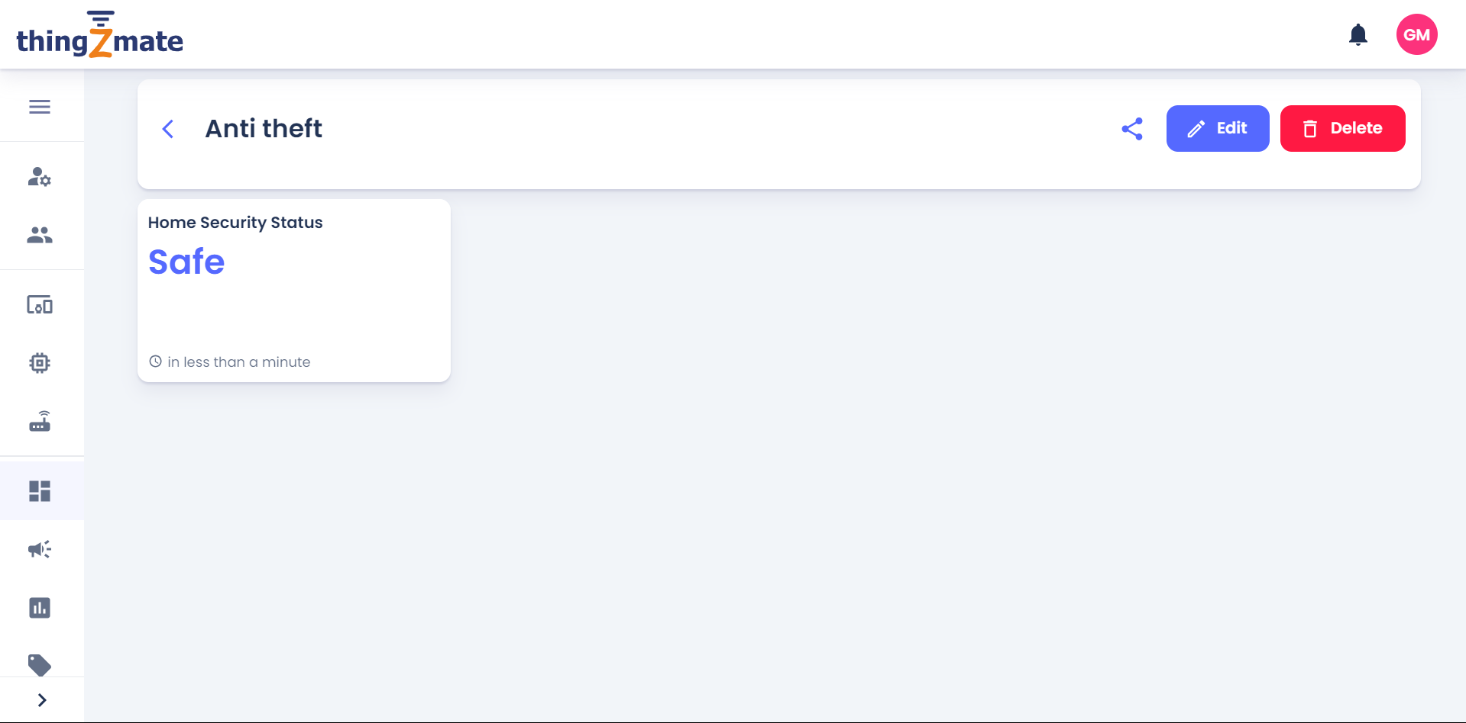

17

**CONCLUSION**

The development of an anti-theft security system using an ESP32, PIR sensor, LED, and buzzer offers a simple yet effective solution for enhancing security in various environments. This project demonstrates how readily available electronic components can be integrated to create a responsive system that detects motion and immediately triggers visual and audible alarms. The ESP32's versatility, combined with the reliability of the PIR sensor, ensures that any unauthorized movement is quickly detected and reported. This system provides a cost-effective, scalable, and efficient means of securing property, making it a valuable addition to homes, offices, and small businesses.

18